ECA0901 – DIGITAL SIGNAL PROCESSING

C02-A3 SIMULATION EXPERIMENT – 8
Realization of FIR Filters Using Direct, Cascade and Linear-Phase Structures Using MATLAB
CODE:
clc; clear; close all;

% FIR coefficients (symmetric)
h = [1 2 3 4 3 2 1]/16;
N = length(h)-1;
Fs = 1000;
x = [1 zeros(1,127)]; % Unit impulse

% Direct realization
y1 = filter(h,1,x);

% Cascade realization using polynomial factorization
r = roots(h);
p = poly(r);
y2 = filter(p,1,x);

% Symmetry and linear-phase check
disp('FIR Coefficients:'); disp(h);
disp('Coefficients are symmetric:');
disp(isequal(h,fliplr(h)));
disp('Maximum output difference:');
disp(max(abs(y1-y2)));

% Impulse and output responses
figure;
subplot(2,1,1);
stem(0:127,y1,'filled'); grid on;
title('Direct and Cascade Impulse Responses');
xlabel('n'); ylabel('Amplitude');
hold on;
stem(0:127,y2,'r');

% Phase response
[H,f] = freqz(h,1,1024,Fs);
subplot(2,1,2);
plot(f,unwrap(angle(H))); grid on;
title('Linear Phase Response');
xlabel('Frequency (Hz)'); ylabel('Phase (radians)');

% Output comparison
figure;
plot(0:127,y1,'b-o'); hold on;
plot(0:127,y2,'r--');
grid on; legend('Direct','Cascade');
title('Output Comparison');
xlabel('n'); ylabel('Output');

OUTPUT:
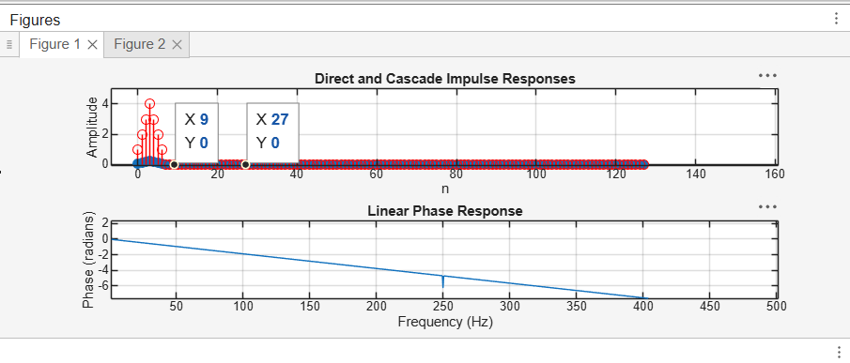

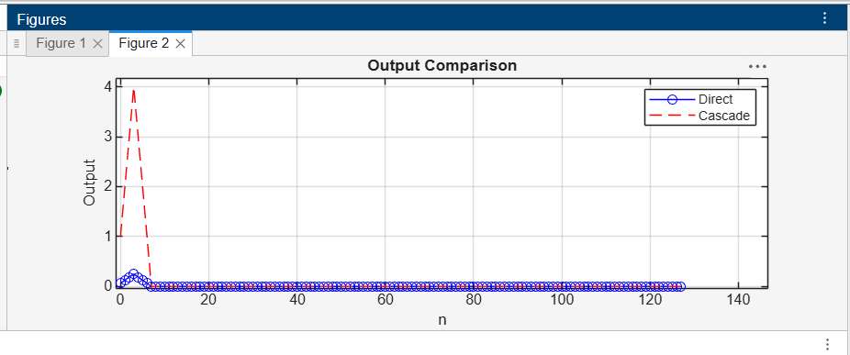
OUTPUT PARAMETERS:
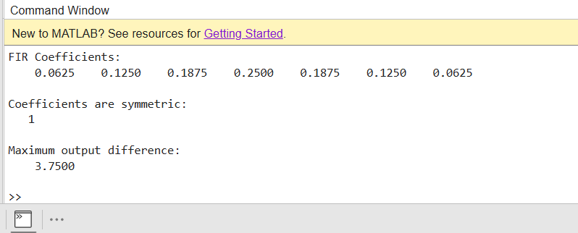

RESULT:
The FIR filter was realized using direct and cascade structures. Symmetric coefficients and linear-phase behaviour were verified, and both outputs were compared to confirm functional equivalence..

